**RTA**

**REPORTS ANALYSIS 1**

**A.M. Session**

**Name:__________________**

## Reports Analysis 1 Class Outline

End Of Period Processing

Understanding different types of reports

**EOP Report Checklist**

Report Defaults & Settings

Vehicle Lists

1. Vehicle Aging MVG
2. Replacement Budgeting RVY/RVR/RVU
3. PM Inspection Reports VV/VD/VL/VK
4. Vehicle Status VA

Vehicle Costs

1. Operating Cost RCP
2. Total Cost RVV/RVD
3. Cost per Mile/Hour/Kilometer RCV/RCE/RCO/RCY/RCM/RCA
4. Vehicle Cost Audit RVA

Fueling

1. Fuel Transaction Lists FFLO/FFLC
2. Fuel Billing RFD/RFC/RFA

**Parts Inventory**

1. Parts Inventory Lists MPLx
2. Low-Use Parts RPL
3. Vendor Quote Sheet PPE
4. Open PO Lines PPL
5. PO Transactions RPT
6. PO Receipts by Invoice/Vndr RPR
7. PO Receipts by Account # RPN
8. Parts Usage RPA
9. Parts Adjustments RPP
10. Parts Activity RPC
11. Parts Gain/Loss RPG
12. Part Warranties RWP/RWF/RWT

## End of Period

Although the End of Period (EOP) process is very easy to run, many of you have questions on what happens to your data and what should be done beforehand. Listed below are answers to some of the most frequently asked questions regarding EOP.

## What is End of Period?

The EOP process adds the usage and costs from current period to year-to-date and life-to-date totals. The current period totals are then cleared allowing usage and costs for the new period to be tracked. Although it is not necessary to run EOP to use the RTA system, we do recommend doing so. By looking at period reports, you may notice trends in costs, things out of the ordinary, and you may even catch some data entry errors.

## How Long is a Period?

A period in RTA is not based on dates. A period is simply the time between running EOPs. For example, if you ran an EOP September 1st and then ran EOP again on September 30th, your period was September 1 through 30. This example happens to coincide with a month, but it does not have to. You decide how long a period is—a week, a month, a quarter, or any period of time that is right for your fleet’s reporting needs.

## What if All My Data Has Not Been Entered?

Suppose it is March 1st and the next EOP is supposed to be run, but because some employees have been away from the office (such as attending RTA’s User’s Conference), all of February’s data has not been entered yet. What do you do? You have two options:

**Option 1**: Hold off on entering any data for the new period until all data from February has been entered and then run EOP. It may be March 5th by the time you finish entering in February’s data but, again, the date EOP is run is irrelevant. What matters is the data that has been entered since the last time EOP was processed.

**Option 2**: Process EOP on March 1st and enter the rest of the data afterwards. The cost and usage will then be accounted for in the next period. **NOTE:** Certain reports are date based and others are period based. Date based reports will allow costs to be grouped by date regardless of which period they were entered into the system. Period based reports lump costs together based on the period they were entered, regardless of dates. Refer to the “Understanding How Data is Stored in RTA” section.

***Will “Old” Data Affect My New Period Costs?***

This is not a perfect world and it seems that as soon as you run EOP, data for the previous period turns up. If you enter it into the system after EOP has been run, it will usually affect costs for the new period—even if you backdate the entry. But, of course, this only affects period-based reports, and will not affect date-based reports. The period-based reports will show the data in the new period, whereas the date-based reports will show the data on the date you’ve backdated it to.

## Do I Need to Close All My Work Orders Before Running EOP?

It will depend on your reporting and billing needs. RTA has various reports to try to accommodate every fleet’s needs. Some reports reference the work order close date, others are based on posting dates, while others are based on the costs entered in the current period and do not rely on dates at all. Work orders only have to be closed if both of the following are true: 1. WO billing reports based on the closed-date of the WO are used (such as the ROD report discussed later); and 2. All work performed must be billed in the month in which it was done.

NOTES:

## Which Reports Do I Need to Print Before Running EOP?

One of the steps that should be done before processing EOP is printing reports. This step is not required; however, printing and reviewing reports will provide information that can help in managing the fleet. Where are most of the expenses incurred? Can these expenses be eliminated or reduced? Are the expenses a result of driver abuse, accidents, or road calls? Which vehicle make, model, or year has better performance? Which facility or department has the lowest maintenance cost? Various reports in the RTA system can help to answer all of these questions or other questions you may have. Reviewing reports can also point out unusual information. For example, if a vehicle or department is showing an unusually high cost this period, this could be researched to determine the cause. Is this a result of erroneous entries made in the system or is this cost valid because more damage costs were incurred this period due to extreme weather conditions?

The RTA system contains over 100 standard reports. We have listed some reports along with the access path in the “EOP Report Check Sheet” section. There is not a specific set of reports that *need* to be printed beforehand. Chances are you will not need or want to print every report. We recommend that you print or view each report in RTA for a small range of vehicles and/or dates to determine which reports will best meet your needs. Make a list of the reports that provide the information you need and use that list when you process EOP. Many of the reports can be printed at any time and do not have to be run just because you are processing EOP. However, there are certain period based reports that are affected by the EOP process. Once the current period has been closed, the cost data for that period is no longer available because it has been added to the year and life totals. Reports affected by EOP are marked with “**\***” in the “EOP Report Check Sheet” section. If these reports are on the list of reports needed by your fleet, make sure they are printed prior to closing the period.

## Understanding How Data is Stored in RTA

The EOP process is easy to grasp once you understand how data is stored in RTA. RTA stores period costs as well as individual transactions in various data files. For example, when a $25.00 part is posted on a work order, $25.00 is added to the parts cost for the period (in one file) and a detailed transaction for $25.00 is written to another file. Think of the file that stores the period costs as a cash register, adding up each amount “sold” or posted in RTA. Only the amounts are put in the cash register so you do not know what the amounts are for or where they came from, you only know that the money was spent during this period. If you wanted to know what the money was spent on, you would have to look at all your “receipts” and “invoices”—or the detailed transactions. You could look at various reports such as fuel transactions and work order transactions to see exactly when the money was spent and what it was spent on. For example, the Cost Per Unit and Total Vehicle Cost reports are period based reports. They only print totals based on entries made during the period through the Work Order, Fuel, Parts, Tires and other modules in RTA—they don’t print an itemized list that make up the totals. Suppose one of the cost per unit reports shows $200 in fuel cost for a vehicle that normally averages $100 in fuel cost per month. To see why this number is high, you could print the Fuel Transaction report (FFL*x*). The Fuel Transaction report is a transaction-based report; therefore, each fuel entry made for this vehicle this period is available for review.

NOTES:

## Different Types of Reports

As previously mentioned, there are over 100 standard reports in RTA. Have you ever printed a few reports and wondered why the totals came out differently on various reports? This is due to various reports using different criteria to gather data that can indeed cause valid differences in your report totals.

This sample work order will demonstrate how the numbers can come out differently on just this *one* work order. Imagine the hundreds of work orders you have input into the system and you will see what a difference each report makes.

DATE: 10/19/2013 RON TURLEY ASSOCIATES, INC. ID: 3-413 PAGE: 1

Time: 01:53 p.m. W O R K O R D E R WO# 005-0000125 CLOSED

CUSTOMER: 005 230 230 SHOP: 005 CSK

GLENDALE DIVISION RON TURLEY ASSOCIATES, INC.

5925 W. STATE AVE. 20823 N. 19TH AVE.

GLENDALE AZ 85301 SUITE 4

PHOENIX, AZ 85027

602-849-8570 623-581-2447

Veh# > 005-1202 Make > GMC 2DR 2WD IN > 09/28/2013 13:28 Priority > 6 SCHEDULED

Odom > 47818.0 Yr-Model > 1998-JIMMY T510516 OUT > 10/03/2013 13:53 Reason > 13 SCHEDULED

Dept > 230 Ser Num > 1GKCS18W5WK517222 PO# > Shop ID >

TRANS TRANS REPAIR HOURS/ PRICE/ TOTAL

NUM LN TYPE DATE SYSTEM PART # DESCRIPTION TYP MECH QTY WAGE COST

----- -- ----- ---------- ----------- --------- -------------------- --- ---- ------ -------- --------

4 1 LABOR 09/28/2013 066-003-000 N/A PM C PM 0002 1.00 70.000 70.000

1 1 PART 09/28/2013 066-003-000 15W40D OIL 15W40 DRUM 205L PM N/A 5.00 2.084 10.420

2 1 PART 09/28/2013 066-003-000 L190 FILTER OIL PM N/A 1.00 8.970 8.970

3 1 PART 09/28/2013 066-003-000 M12969457 FILTER AIR PM N/A 1.00 63.600 63.600

5 2 LABOR 09/28/2013 023-001-002 N/A PAD - CLUTCH PEDAL RPL 0001 0.30 40.250 12.075

7 2 LABOR 09/29/2013 023-001-002 N/A PAD - CLUTCH PEDAL RPL 0001 0.25 40.250 10.063

6 2 PART 09/29/2013 023-001-002 3081866 CLUTCH PAD RPL N/A 1.00 69.200 69.200

**8 3 LABOR 09/29/2013 045-002-000 N/A CYLINDER BLOCK & CRA RPL 0001 2.50 40.250 100.625**

9 3 LABOR 10/02/2013 045-002-000 N/A CYLINDER BLOCK & CRA RPL 0001 3.15 40.250 126.788

10 3 LABOR 10/03/2013 045-002-000 N/A CYLINDER BLOCK & CRA RPL 0001 1.60 40.250 64.400

11 3 PART 10/03/2013 045-002-000 C6860 CYLINDER ASY RPL N/A 1.00 781.182 781.182

LABOR HRS 8.80

NOTES: RAN END OF PERIOD ON 10/01/2013. LABOR $383.95

**TRAN #8 REALLY POSTED ON 10/02/2013 AFTER EOP** PARTS $933.37

**BUT THE POSTING DATE WAS BACK-DATED TO 09/29/2013** TIRES $0.00

TO REFLECT WHEN THE TRANSACTION ACTUALLY OCCURRED WRNTY $0.00

OUTSIDE $0.00

OVERHEAD $0.00

TAX $0.00

MISC $0.00

=============

TOTAL $1,317.33

## Lists

Lists *generally* reflect detail for a particular item and do not contain accumulative cost information. For example, a vehicle list will print information such as vehicle number, make, model and year. A part list will print the part information such as part number and description as well as quantity on hand.

## Period Reports

Period reports accumulate totals as entries are made regardless of the date of the transaction. The current period contains costs posted since the end-of-period was processed. For example: if the first seven transactions were posted in the period before EOP was processed and then the remaining four transactions were entered later, the reports would show the following in the first period (September):

|  |  |  |  |
| --- | --- | --- | --- |
| **Labor Hours** | **Labor Costs** | **Part Costs** | **Total Costs** |
| 1.55 | $ 92.14 | $ 152.19 | $ 244.33 |

If nothing else were entered in the second period (October), the reports would show the following in the second period—even though the 8th transaction shows a date in the previous period:

|  |  |  |  |
| --- | --- | --- | --- |
| **Labor Hours** | **Labor Costs** | **Part Costs** | **Total Costs** |
| 7.25 | $ 291.81 | $ 781.18 | $ 1,072.99 |

Generally, period reports are easy to spot because they print totals for current period, year-to-date, and life-to-date, or they will prompt you to select only one of those periods before generating the report. A few examples of period reports are listed below.

* Cost per Unit by Vehicle (RCV)
* Total Vehicle Cost by Department (RVD)
* Fleet Cost by Period (RFP)
* Mechanic Productivity (RE*x*)
* Parts Inventory Balance (RPI)

## Transaction Reports: Post Date

Transaction reports by post date will print totals based on the dates you select. The posting or transaction date is used for these types of reports. For example, if you ran the WO Transaction report by Vehicle (after 10/02/2013) for the date range 09/01/13 through 09/30/13, the report would print all the detail for those dates, and your grand total would show:

|  |  |  |  |
| --- | --- | --- | --- |
| **Labor Hours** | **Labor Costs** | **Part Costs** | **Total Costs** |
| 4.05 | $ 192.76 | $ 152.19 | $ 344.95 |

If nothing else were entered in the second period (October) and you ran the WO Transaction report by Vehicle from 10/01/13 through 10/31/13, the report would print all the detail for those dates, and your grand total would show:

|  |  |  |  |
| --- | --- | --- | --- |
| **Labor Hours** | **Labor Costs** | **Part Costs** | **Total Costs** |
| 4.75 | $ 191.19 | $ 781.18 | $ 972.37 |

It is pretty easy to figure out where the numbers come from on transaction reports by post date because you simply look at the individual transaction posting date; if the transaction is in the range, it is included. These types of reports are great for accounting for items the minute costs are incurred regardless of whether the job is done or not. A few examples of transaction reports by post date are listed below.

* Vehicle Cost Audit Report (RVA)
* PO Transactions (RPT, RPR )
* Part Usage by WO (RPA)
* Fuel Transactions (FFLO, FFLC)
* Fuel Billing by Dept., Customer, or Acct. (RFD, RFC, RFA)
* WO Transactions by Vehicle (ROV)
* WO Cost Summary by Transaction Date (ROT)

NOTES:

## Transaction Reports: WO Close Date

These types of reports will print totals based on the work order close dates you select. The totals will include the entire work order cost and not just the transactions posted between the dates specified. For example, if you ran the WO Cost Summary by Customer/Date from 09/01/13 through 09/30/13, the report would print nothing even though you posted some transactions in September. If you ran the same report from 10/01/13 through 10/31/13, your report would show the following totals:

|  |  |  |  |
| --- | --- | --- | --- |
| **Labor Hours** | **Labor Costs** | **Part Costs** | **Total Costs** |
| 8.80 | $ 383.95 | $ 933.37 | $ 1,317.32 |

In this scenario, all of the costs would be accounted for when all of the work is complete. Even though some of the work was done in September, the entire job was not finished until October. A few examples of transaction reports using work order close dates are listed below.

* Repair by Work Type (ROR)
* WO Cost Summary by Customer/Date (ROD)

## Transaction Reports: Highest Date

There are the reports that print totals based on the highest post dates you select. The totals will include the entire work order line cost and not just the transactions posted between the dates specified. For example, if you ran the Vehicle Repair History report for only 09/29/2013, the report would show the following totals:

|  |  |  |  |
| --- | --- | --- | --- |
| **Labor Hours** | **Labor Costs** | **Part Costs** | **Total Costs** |
| .55 | $ 22.14 | $ 69.20 | $ 91.34 |

This comes from the posted items for line 2 (transactions 8, 9, and 10 on our sample work order). This job was worked on for 2 days, 09/28/13 and 09/29/13. This particular report uses the highest/most recent date to figure the job completion date and then reports the entire job cost (i.e. all the costs posted to that work order line). This is a nice report to run to find out what jobs were completed during a specific time and what the total costs were for those jobs regardless of whether the work order is still open or closed. If you ran this same report for 10/02/13, you would get nothing because even though there was a transaction posted on 10/02/13, there were no jobs *completed* on that date. If you ran the report for 10/03/13, the report would show the following totals:

|  |  |  |  |
| --- | --- | --- | --- |
| **Labor Hours** | **Labor Costs** | **Part Costs** | **Total Costs** |
| 7.25 | $ 291.81 | $ 781.18 | $ 1,072.99 |

A few examples of transaction reports by highest date are listed below.

* Vehicle Repair History (RRV)
* Vehicle History Summary (RRS)

NOTES:

## End of Period Report Checklist

|  |  |
| --- | --- |
| System  * Facility Listing (MFL)* * Facility Listing Summary (RA)  Work Orders  * Repair Code Detail (ROR) * Part and Labor Usage (ROV) * WO Parts Usage (RPA) * WO for customers (WLC) * Accountant Report (ROT, ROD)  Mechanic: After Running Weekly EOP (SEW)  * Productivity Report (REP)* * Indirect Labor (REI)* * Hours Paid Report (REH)* * Shop Labor Recap (RES) * Paid vs. Indirect Labor (REV)*  Paperless Shop  * Accountability Report (RSA) * Time Card (REM) * Recap Report (RSL)  Parts and Purchase Orders  * General Part Usage (RPU) * Inventory Balance (RPI)* * Part Listing (MPLx) * Inventory Adjustment (RPP) * Purchase Order Received (RPT) * PO Summary (PPV) * Warranty Report (RWT) * Manual Charge Out (PAP) | Vehicles  * RVA Cost Audit Report (RVA) * PM report (VD, VV) * Cost per unit (RCE, RCV)* * Operating cost (RCP)* * Total Cost (RVD, RVV)* * Misc. Cost Report (RVB)* * Initialize Cost Report (SEC)* * Fleet Cost Report (RLP) * Cost Summary Report (RLC)  Fuel  * Closed Transactions (FFLC) * Variance Report (FPV)* * State Tax Report (RFS)* * Vehicle Tax Report (RFV)* * End of Month Fuel Tax (SEF) * Fuel Billing (RFD, RFC) * Vehicle Taxes by State (RFF)*  Tires  * Tire Replacement (RIR) * Scrap Tire Failure (RIS) * Manufacturer Cost (RIM) * Capper Cost (RIC) * Scrap Tire History (RIP) * Tire Inventory Report (MTL) |

## Denotes - You will not be able to obtain the reports after EOP is processed.

## Report Print/View Features

**Print/View Defaults:** This user-definable setting allows each user to set the default operation when processing a report. The default is setup in the User File Maintenance (SUM) and the options are Print Only (go directly to the printer), Prompt Print (prompt for print/view with Print being the default), Prompt View (prompt for print/view with View being the default), and View Only (go directly to the viewer).

**Viewer Screen Defaults:** When you view a report on the screen in the Standard format, the system will now remember the font size, window placement and size of the preview window. The next time you view a report in the Standard format, these user-specific saved settings will be used.

## New Report Features

RTA reports have been modified with new enhancements in the past few releases.

* More reports are now available in the Advanced print format.
* Option to run numerous reports for a specific Facility or a Region, replacing the previous prompts for the starting and ending facility. Tip: If you run reports for first to last facilities create a Region (screen MFR) of ALL, then select each facility listed.
* Many more reports have been modified to export to a file. This file can be viewed using a text editor, word processor, or spreadsheet software.
* Reports will now return to the prompt screen after processing to allow you to rerun it for another range without returning to the main menu and having to select the menu options again.

## Advanced Report Printing

Many reports are designed to a presentation-ready in a graphical format. The report utilizes the “RPV Reports Viewer” development tool to allow for nicer fonts, user-definable bitmap in the header, highlighted and reverse-highlighted text, and an overall improved presentation. The past few major updates have included many more reports available in the Advanced format.

A setup switch must be enabled in your system in order to print the Advanced format. In the Main System Parameters screen (SSM), line #12 must be set to Advanced, and the Workstation CD must be installed on the computer running the report.

Other features of the RPV Reports Viewer include:

* Text highlighter
* Add colored checkmarks
* Input notes and comments
* Zoom in and out
* Find/search for text
* Email reports (certain email packages only)
* Create PDF
* Export to Excel, CSV, or text
* Save/retrieve reports

Note the custom bitmap showing the RTA logo in the upper left corner, which is user-definable and will print on most Advanced reports. This could be a company logo, fleet department logo, or any other custom bitmap. The file *report.bmp* can be changed to print another image, but the file aspect ratio must remain 2:1 in width vs. length, so the image must be twice as wide as it large, to fit properly in the space provided.

## VEHICLE AGING REPORT

MVG

The Vehicle Aging Report lists vehicles that are older than *X* years and/or over *X* miles. It can be run for a range of vehicles, classes, or departments. The report can select vehicles over *X* years, or over *X* miles, or over years *and* miles, or either miles *or* years. The Purchase-Date is used to determine the years.

DATE: 02/01/2008 BILL KIFF TRUCKING ID: 1-38/MVG PAGE: 1

TIME: 02:19 p.m. VEHICLE AGING REPORT BY VEHICLE

FACILITY: 0007

VEHICLE: First TO Last

MILES: 100000 OR YEARS: 10

VEHICLE YEAR MAKE MODEL CLASS DEPARTMENT PURCH DATE IN SVC DATE PURCHASE PRICE LIFE MILES

-------- ---- --------------- --------------- --------------- ---------- ---------- ----------- --------------- ------------------

049 1995 FORD TAURUS CAR 1402 06/23/1995 06/28/1995 15,556.000 57,501.0

357 1987 TRAILMOBILE 07AN TRL 1402 09/15/1986 10/31/1986 25,665.000 693,111.0

449 1994 PETERBUILT 359 3AX 1404 09/15/1993 09/30/1993 89,050.000 222,003.0

450 1994 PETERBUILT 359 3AX 1404 09/15/1993 09/30/1993 89,050.000 214,881.0

499 1994 PETERBUILT 359 3AX 1402 09/15/1993 09/28/1993 89,050.000 206,422.0

546 1991 NISSAN CPH01 LFT 1401 12/14/1990 12/30/1990 28,501.000 22,641.0

R357 1993 THERMO KING SB1200 RFR 1402 03/19/1993 03/31/1993 12,115.000 7,841.0

NOTES:

## VEHICLE REPLACEMENT BUDGETING

RVY, RVR, RVU

A Vehicle Replacement Budgeting program allows the fleet to project and budget for future replacements, even down to including inflation and upfitting charges. Vehicle replacement schedules can be setup by class and year, and more specific replacement schedules for particular vehicles can be setup to override those defaults.

Three replacement reports are available to be processed for a range of vehicles, classes, or departments.

**Replacement Year Projection (RVY)**

This report lists all vehicles due to be replaced, based on the replacement year, and their replacement values by year. The report can be processed for up to five concurrent years and also provides totals of the replacement costs for the vehicles included by year.

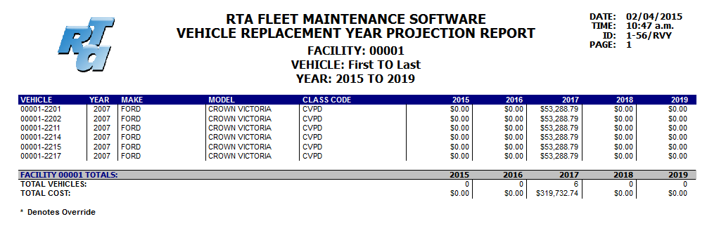

NOTES:

**Replacement Cost Projection (RVR)**

This report lists all vehicles due to be replaced for up to five concurrent years, based on the replacement year. The replacement cost and resale values are shown for all vehicles due to be replaced in those 1-5 years. Totals by year are shown for both at the end of the report, along with the number of vehicles to be replaced.

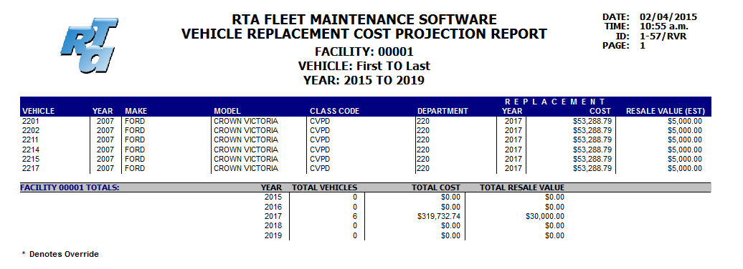

**Replacement Due Report (RVU)**

This report lists all vehicles due to be replaced within a certain number of miles and/or years.

Project Miles will project the life miles based on the year of the purchase date and current life miles.

Miles or Years lists all vehicles due in one or both of those categories.

Miles and Years lists the vehicles that are due in both categories.

Miles Only or Years Only will list only those vehicles due within the selected category.

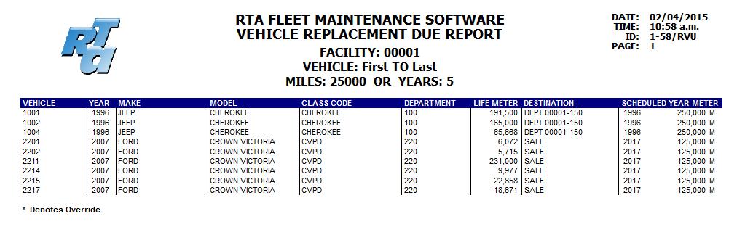

NOTES:

## PM INSPECTION REPORTS

VV, VD, & VK

The PM Inspection Reports list vehicles that are due, past due, or due soon, for an inspection. Options VV and VK sort by the vehicle number whereas option VD sorts the vehicles by department or class. Option VK will include any vehicles linked to a vehicle within the range selected, whether the linked vehicle is within the range or not.

**Prompts**

**Starting and Ending Facility/Vehicle**: The PM report can be processed for a range of facilities and vehicles.

**PM’s by Location**: Printing the PM report by the vehicles’ location allows you to single out a group of vehicles’ PM’s to schedule. This could be used to view vehicles which are parked at different locations, or a group of vehicles in which the repairs are done by a particular mechanic or an outside source (such as fork lifts or refrigeration units). The location is set up in the Vehicle Master Screen (MVM).

**Date Range:** If “Yes” is selected, this will print only PM’s that are due within a particular date range. This may be beneficial if only tracking PM’s by days, or for checking an individual PM that may be tracked only by days (annual inspections). But, this option will not notify you of PM’s due by miles, hours, or kilometers.

**Print PM’s Due** allow those not due to be excluded from the report. When Due is selected, two other options are available: **Exclude Scheduled** will not print any that are already assigned to a work order. **Include other PM’s** provides the ability to show all PM’s for a vehicle if a certain PM is due. For example, a vehicle has an A, B and C PM. But, it is only serviced when the A PM is due. The report can be run for just A PM’s that are due, and if it is due then also print the B and C. If you include other PM’s, the **Due Only PM’s** becomes available to print the B & C PM (from the previous example) only if they’re due.

**Email PM Notifications:** This option will send an email for each individual PM that is due or within the parameters you input. The emails are sent to the Operator (via the Employee file) and the Department.

**Due Within XX units:** The PM Report will show vehicles’ PM’s due within a certain day, mileage (kilometers), hour, gallon, and up to four alternate meter intervals. The default intervals are set in the Misc. Parameters screen (SSI**)** line 11, but you may find occasions to modify these as you are printing the report. For example, the shop may be rebuilding an engine or two, or a couple mechanics may be attending the RTA Conference, which would entail lowering the intervals to allow you to only see the most due PM’s. On the other hand, you may have a few vacations coming up next month and would like to extend those intervals to get slightly ahead.

**Starting and Ending PM Code:** This prompt allows you to specify a range of PMs to print. The default is “A” to “Z9”, or to include all.

**Auto-Create WO’s:** The RTA system allows you to automatically create Work Orders directly from the PM reports. If you answer “Yes” to *Create WO’s for Due PM’s*, it will prompt for a template WO number, which is used to fill in the header information of the Work Order if a template is not specified in the vehicle’s PM screen. The PM report will create Work Orders for any PM’s that are past due, due now, or due within the range you specify. It will not create Work Orders for any PM’s that have a Work Order line still pending for the specified PM or one that nests it.

NOTES:

Following is a quick look at the specifications of this program:

1. Work Orders will *only* be created for those vehicles listed on the accompanying PM report and *only* for those which show as “Due...”. If only J PM’s are specified, work orders will only be created for J-PM’s due.
2. Work Orders are *not* created if an open work order line already exists for the specified PM, or if that PM is “nested” within another PM that has an open work order line.
3. One Work Order is created per vehicle; a separate line is created for each individual PM due which is not nested with another PM.
4. A Template Work Order must be used in conjunction with this option. This template is used for the Priority, Reason, and Shop ID codes, the Line and Master Notes, and the Checklist.
5. If a template WO is assigned in the corresponding vehicle’s PM, the template work order is used.
6. If a template is not assigned in the vehicle‘s PM file, the template specified when running the PM report will be used. In this case, the WO line brings in the VMRS code directly from the vehicle’s PM screen for that due PM. The line’s Repair Type Code comes from the first line on the template Work Order, and the header information is filled in from the template.
7. An * prints next to the interval column to indicate that the interval is LOCKED.

Sample PM Report (VV/VD):

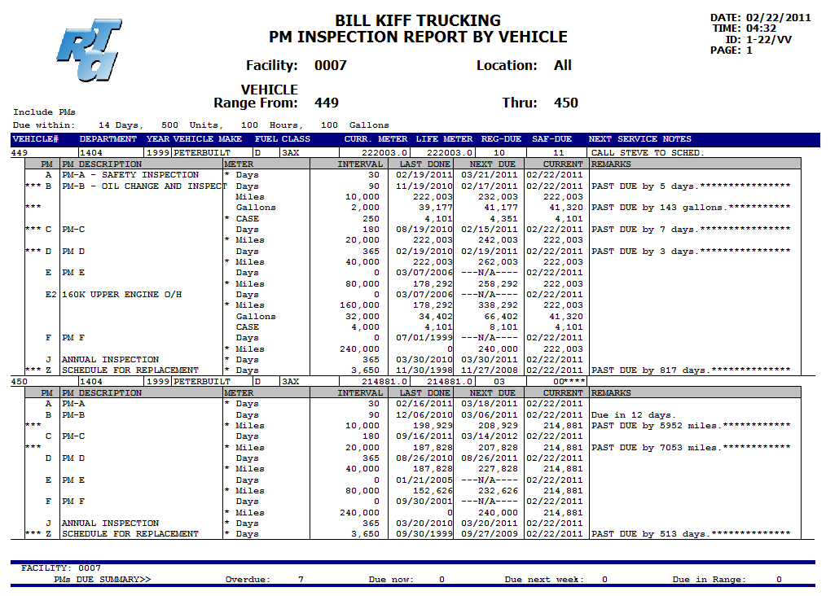

**List PM’s Due (VL)**

This PM report option is very similar to reports VV & VD but has two added features:

* You may “pick-and-choose” which PM’s to create work orders for.
* Estimate work orders can be created for due PM’s in addition to regular work orders.
* The list can be printed.

**VEHICLE STATUS**

VA

The Vehicle Status screen showing the current status of each vehicle can be printed or exported to a text file. This makes it easy to send a list of vehicles and their current status to a Dept Mgr, Dispatch, Transportation Director, etc. The list can be selected for a department, customer vehicle class or a range of vehicle numbers.

The list can also be displayed as a standalone screen that updates every 5-60 minutes and can scroll through the vehicle list page by page, .

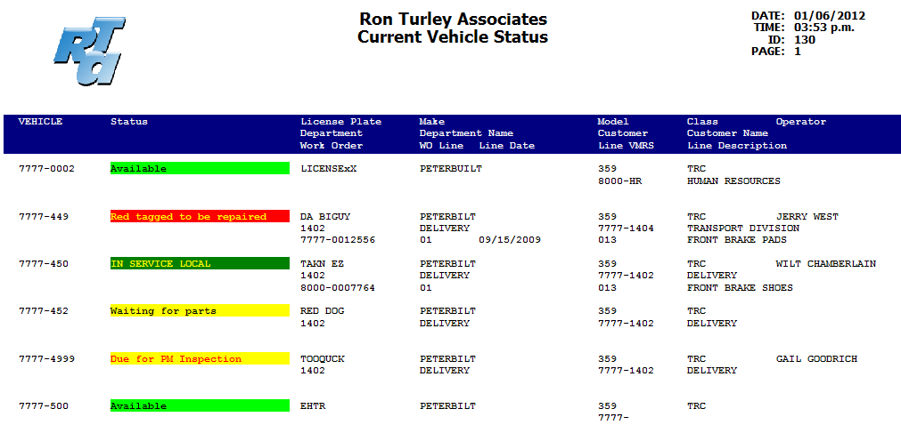

**VEHICLE OPERATING COST REPORT**

RCP

The Vehicle Operating Cost report is a concise vehicle total cost and cost per mile report. This report prompts for a range of departments, and it is sorted and subtotaled by department. The information gathered is from the data in the vehicle costs buckets, and can be selected for the current period, year to date, or life to date. The report also prompts to use the standard meter or one of the alternate meters to calculate the cost per mile columns. Included in this report is all costs posted through the work order and fueling modules. Fixed costs are not included. The report also includes a prompt to *Include vehicle specs.*, which, if selected, prints an additional line per vehicle showing the year, make and model.

**Base Miles:**

If a vehicle was purchased prior to running the RTA system, or if a used vehicle is purchased, the Base Miles field in the vehicle master screen can be used. Miles entered into the Base Miles are removed from the total life miles and “cost per” calculations.

The columns listed:

vehicle number

units (miles, hours, kilometers, alternate meter units, etc)

fuel gallons or liters

units per fuel (e.g. miles per gallon)

fuel cost rounded to nearest dollar

fuel cost per unit in cents

lubricants cost rounded to nearest dollar

lubricants cost per unit in cents

maintenance cost (parts, labor, misc, warranty, outside) rounded to nearest dollar

maintenance cost per unit in cents

tire cost rounded to nearest dollar

tire cost per unit in cents

total cost of all of the above rounded to nearest dollar

total cost per unit in cents

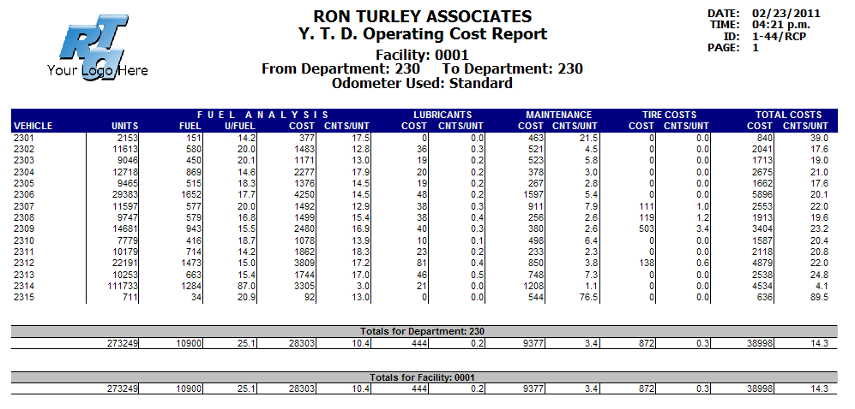

**TOTAL VEHICLE COST REPORT**

RVV or RVD

The Total Vehicle Cost report prints all accumulated costs associated with the vehicles and summarizes them for the current period, year-to-date, and life-to-date, one of the most important reports for any fleet. This report should be one of the month-end reports printed or saved just prior to processing the End of Period Vehicles. The data gathered for the current period will not be available in this format after running the End of Period. The vehicle costs are taken from the “vehicle cost buckets”and placed in an easy, readable format.

This report can be processed for a range of vehicles, a range of departments, or for a range of Class Codes with subtotals for each. The report can be printed showing all *detail*, or a *total page* only.

The first line shows the vehicle number, year, make, model, meter base (mileage, kilometer, hours, gallons, or units).

The data for each vehicle is divided into three lines, PD=current period; YR=year-to-date; LF=life-to-date. The current period data contains figures *since the last End of Period Vehicles was processed.*

**Field Descriptions:**

Meter Units: miles, kilometers, hours, gallons, or units depending on the meter base.

Fuel Quantity: fuel gallons or liters

Lubricant Quantity: total lubricants, including PM oil, add oil, hydraulic, gear, and ATF

Revenue: revenue dollars generated in the fueling module truncated to nearest dollar

Tire Cost: tire costs posted, including tires posted in the tire module and work orders, outside tires posted, and parts posted which are flagged as a “tire type”, truncated to nearest dollar

Misc. Cost: miscellaneous costs posted in the work order module truncated to nearest dollar

Labor Hours: labor hours posted in the work order module truncated to nearest dollar

Parts Cost: parts costs posted in the work order module truncated to nearest dollar

Outside Repairs: outside parts and labor posted in the work order module truncated to nearest dollar

Total Repair Cost: total of labor, parts, and outside (tire and misc. costs not included)

**Total Vehicle Cost:** total cost of the vehicle, including repair costs, tires, misc., fuel, oil, and fixed costs; **this field represents the entire cost for this vehicle**

Days Used: days utilized, updated in the fueling module

Days Possible: days possibly utilized, current month updated when running end of period vehicles

Days Percentage: days used divided by days possible to show a utilization percentage

Details Section:

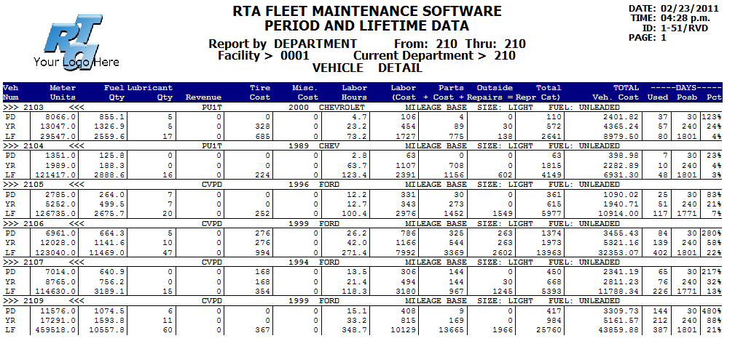

The bottom portion will print a grand total of all vehicles within the ranges selected. If the report by department is processed (RVD), a subtotals page will also print for each individual department.

The Sub-Totals(Hour) are the vehicles whose main meter is set to Hours, all others are included in the Sub-Totals(Miles) category.

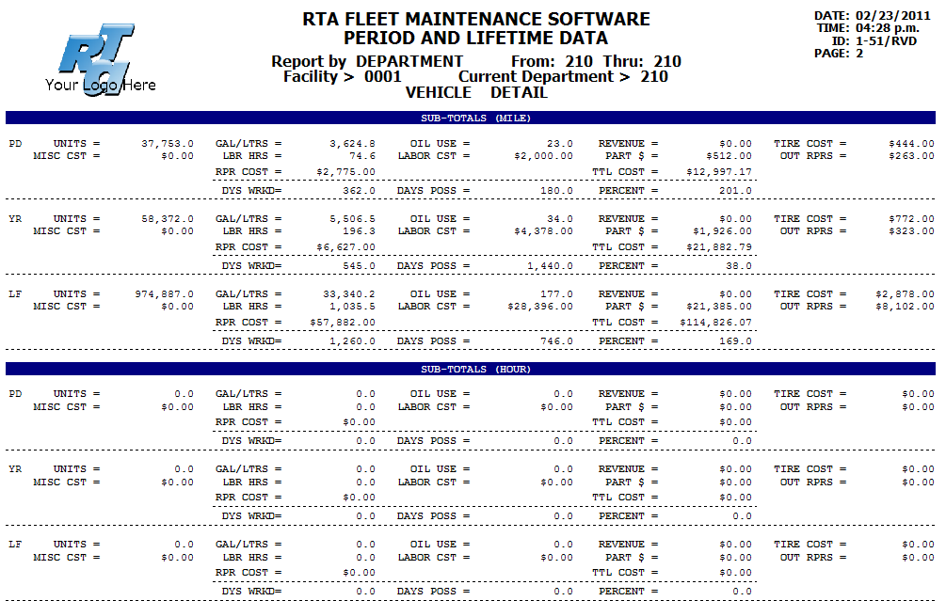

NOTES:

# COST PER MILE REPORTS

RCV, RCE, RCO, RCY, RCM, RCA

The Cost Per Mile report can be called the “sister” to the Total Vehicle Cost reports. The data used is almost identical but is presented in a “per mile” (or “per unit”) format. This report should also be printed or saved just prior to the End of Period Vehicles processing; the current period data will not be available in this easy-to-read format after EOP.

**Report Prompts:**

There are six different options to select and subtotal the data:

RCV/1-431 prompts for a range of vehicle numbers or class codes

RCE/1-41 prompts for a range of department numbers and subtotals each department

RCO/1-421 prompts for a single vehicle make and year combination

RCY/1-422 prompts for a single vehicle year

RCM/1-423 prompts for a single vehicle make

RCA/1-424 prints all vehicles in year-make order

The data for each vehicle is divided into three lines, PD=current period; YR=year-to-date; LF=life-to-date. The current period data contains figures *since the last End of Period Vehicles was processed.*

The *Report Type* and *Meter Type* prompts determine which “units” field will be used to determine the cost per ___. The one selected will be the number shown in the *Units* field, and will be used to calculate the *Maint$/Unit, Tire$/Unit, Cost/Unit, Units/Add-Oil, Revenue/Unit,* and *Fixed$/Unit.* The report can be processed for one of the vehicle’s meters, or for the number of gallons or liters of fuel consumed. If *Units* is selected, the *Meter Type* prompt is used to determine which metering unit to use, the standard meter or one of the alternate meters. If *Fuel Consumed* is selected, the vehicles’ gallons or liters will be used for the calculations.

**Base Miles:**

If a vehicle was purchased prior to running the RTA system, or if a used vehicle is purchased, the Base Miles field in the vehicle master screen can be used. Miles entered into the Base Miles are removed from the total life miles on these cost per mile reports.

**Field Descriptions:**

Units/Fuel: This field may also be called “miles per gallon”. The *Units* is determined by the answers to the prompts of *Report Type* and *Meter Type* as described above. This field may contain miles, kilometers, hours, units, gallons, or one of the alternate meters, based on the answers to the prompts. This field can also be switched to use another method for its calculation separate from the rest of the data in the report. The setup switch in screen SSI/8-115 line 20 determines how this field is calculated. The switch can be set to show Miles per Gallon, Liters per 100 Kilometers, Gallons per Hour, Hours per Gallon, Kilometers per Liter, and Kilometers per Gallon. For example, for the Cost Per Mile report to show gallons consumed per hour, but use the Hours meter to determine the other costs per hour, this switch would be set to Gallons Per Hour, and the report would be processed by “units”.

For the following field descriptions, we will use miles in place of “units” for simplicity:

Maint$/Unit: the total of parts plus labor plus outside repairs, divided by miles

Tire$/Unit: total tire cost divided by miles

**Cost/Unit**: this is the total vehicle cost divided by miles. **This field represents the entire vehicle cost per mile**

Units/Add-Oil: total quantity of *Add-Oil* divided by miles; add-oil is only oil that is posted through the fueling module; work order postings of oils, such as oil changes, are *not* included in these calculations

Utilized: days utilized percentage, days utilized divided by days possible

Revenue/Unit: revenue cost generated divided by miles

Accident Expenses: total accident expenses truncated in dollars (also included in maintenance and total cost per mile)

Break Downs: number of breakdowns, currently updated only in the Misc. Work Order option

Depreciation Expense: total depreciation & capitalization from the vehicle’s depreciation schedule

License Expense: total license expenses from the vehicle’s financial info screen

Insurance Expeses: total insurance expenses from the vehicle’s financial info screen

Fixed$/Unit: total of depreciation, license, and insurance costs divided by miles

Units: number of units used for the cost per ____ calculations, which may be miles, kilometers, hours, gallons, units, or one of the alternate meters.

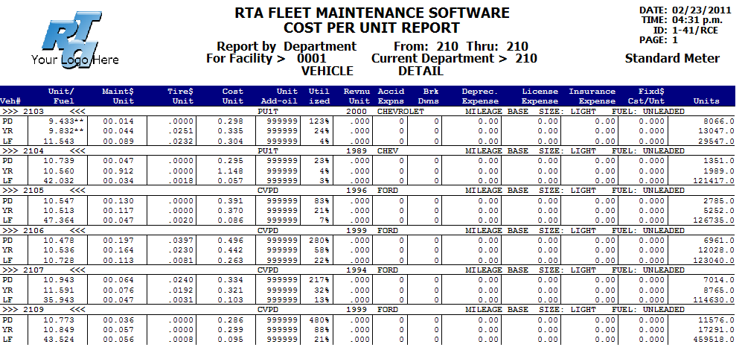

**Subtotals and Totals:**

The totals section contains two groups, the first is mileage based (or kilometer or unit based), and the second is hourly based. The totals area also includes, for those vehicles appearing on the report, the average age and the average date of purchase (calculated using the vehicles’ purchase date). The *vehicles counted* are those that a valid purchase date was found, those *not counted* contain an invalid purchase date or are blank.

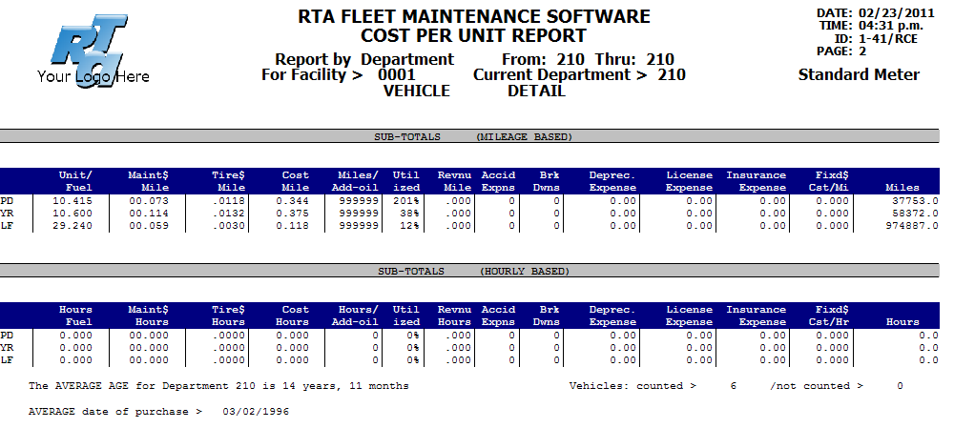

NOTES:

## VEHICLE COST AUDIT REPORT

RVA

The vehicle cost audit file contains a transaction for every cost posted to every vehicle. Transactions come from all work order programs, fueling, tricoder interfaces, tire module, end-of-period, wash module, etc. The audit file is updated anywhere a cost is posted to a vehicle.

The Vehicle Cost Audit Report (RVA) is the first report to utilize this data. The report includes every cost posted to a vehicle, similar to the Total Cost Report (RVV/RVD) discussed previously. The difference is the audit report is based on the transaction date, whereas the Total Cost Report is based on the period/year/life cost buckets. Therefore, it can be processed for any given date range.

The End of Period (SEV) does not affect the data on the report, although EOP does post fixed costs that are included in this report.

This report contains data since RTA version 6.1, released in 2005. Costs posted prior to version 6.1 are not included on this report.

The data can be selected and sorted by Vehicle Number, Department, or Vehicle Class.

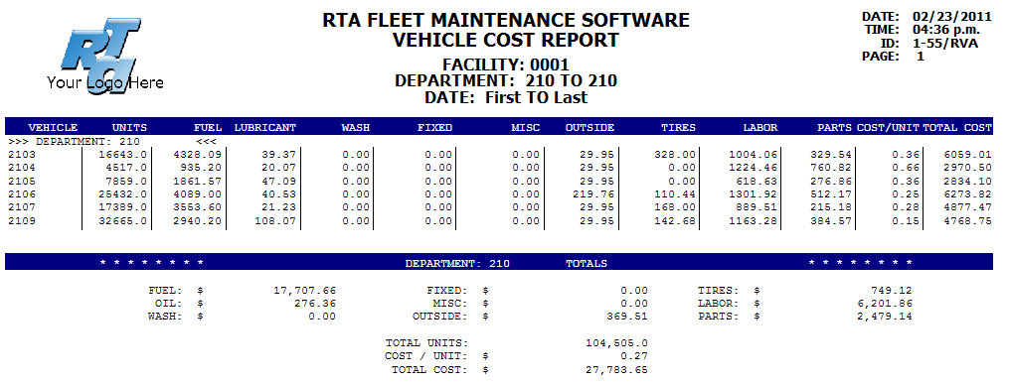

NOTES:

**FUEL TRANSACTION LISTS**

FFLO or FFLC

The fuel transaction lists, either *open* or *closed*, prints every fuel entry and part/oil entries made in the fueling module. These lists make great edits and can quickly be perused to catch a bad mileage or fuel gallon entry. The open transaction list should be reviewed prior to *posting* your fuel to the pumps and tanks. A total of fuel deliveries can be printed by inputting *DROP* as the starting and ending vehicle number. Vehicle washes are listed on the Closed transaction list (FFLC).

This report can be processed by date or by vehicle number. If Date is selected, only fuel transactions that have been posted from the current facility will be listed. If Vehicle is selected, all fuel transactions for the specified vehicles will be listed, regardless of the facility where the vehicle was fueled, and subtotals by vehicle are also available.

Sample report sorted by vehicle with subtotals:

DATE PRINTED-- 01/06/2006 CLOSED FUEL TRANSACTION REPORT ID: 2-26/FFLC PAGE-- 1

Vehicle Range: 0007-First thru 0007-Last

Date Range: 06/01/2003 thru 07/02/2003

TRANS# DATE VEHICLE# ODOMETER TAX? ST MILES TYP GALLONS $/GAL TOTAL $ PUMP CHARGE# PART TYPE PCOST $

------- -------- ------------- -------- ---- -- ------- --- ------- ------- ---------- ---- ---------- ----- ---- ----------

0000161 07022003 0007-007 37239.0 NTBL TN 2759.0 U 221.70 1.8191 403.2900 NONE RECEIPTS 0.0 0.0000

USAGE TOTALS -----> 1 2759.0 221.70 403.2900 PARTS 0.0 0.0000

------------------------------------------------------------------------------------------------------------------------------------

0000162 06022003 0007-049 49339.0 NTBL AZ 0.0 P 0.00 0.0000 0.0000 NONE 1.0 PART 3.3070

0000163 06022003 0007-049 49339.0 NTBL AZ 0.0 A 0.00 0.0000 0.0000 NONE 1.0 ATF 1.5130

0000164 06022003 0007-049 49866.0 NTBL AZ 527.0 U 19.60 2.0970 41.1012 2 0.0 0.0000

0000170 06292003 0007-049 50359.0 NTBL AZ 493.0 U 19.30 2.0970 40.4721 2 0.0 0.0000

USAGE TOTALS -----> 4 1020.0 38.90 81.5733 PARTS 2.0 4.8200

------------------------------------------------------------------------------------------------------------------------------------

0000159 06082003 0007-449 164007.0 TXPD CA 528.0 D 103.20 2.8700 296.1840 NONE 0.0 0.0000

0000175 06182003 0007-449 165116.0 TXPD 0.0 0.00 0.0000 0.0000 NONE WASH 1.0 WASH 25.0000

0000165 06192003 0007-449 164007.0 NTBL AZ 0.0 O 0.00 0.0000 0.0000 NONE 2.0 OIL 2.0780

0000166 06192003 0007-449 164007.0 NTBL AZ 0.0 G 0.00 0.0000 0.0000 NONE 1.0 GEAR 1.5220

0000167 06192003 0007-449 164499.0 COPD AZ 492.0 D 127.50 2.0823 265.4933 1 0.0 0.0000

0000171 06302003 0007-449 165116.0 COPD AZ 617.0 D 127.50 2.0823 265.4933 1 0.0 0.0000

USAGE TOTALS -----> 5 1109.0 255.00 530.9866 PARTS 4.0 28.6000

------------------------------------------------------------------------------------------------------------------------------------

0000172 06132003 0007-499 134535.0 NTBL AZ 0.0 O 0.00 0.0000 0.0000 NONE 1.0 OIL 1.0900

0000173 06132003 0007-499 136366.0 COPD AZ 1831.0 D 134.30 2.1823 293.0829 1 0.0 0.0000

0000174 06302003 0007-499 138107.0 TXPD CA 1741.0 D 282.30 2.3128 652.9000 NONE SHELL 0.0 0.0000

USAGE TOTALS -----> 3 3572.0 416.60 945.9829 PARTS 1.0 1.0900

------------------------------------------------------------------------------------------------------------------------------------

USAGE TOTALS -----> 14 8988.0 1035.400 2258.0168 OIL 3.0 3.1680 ANTF 0.0 0.0000

TRANSFER TOTALS -----> 0 0.000 0.0000 ATF 1.0 1.5130 GEAR 1.0 1.5220

DROPPED TOTALS -----> 0 0.000 0.0000 HYD 0.0 0.0000 PART 1.0 3.3070

MISC 0.0 0.0000 WASH 1.0 25.0000

NOTES:

## FUEL BILLING REPORTS

RFD or RFC or RFA

The fuel billing reports were initially designed to charge departments or customers for fuel and/or oil usage. Although they still handle the billing, they can be used for much more. They provide an excellent summary report for miles (or hours or kilometers) traveled, gallons used, miles per gallon, and any other postings made within the fueling module. The report can be printed by Vehicle to list one line per vehicle with its totals for the range, and a total for the dept./cust.; or by Department/Customer, showing one line per dept./cust. The prompts include starting and ending department or customer range, and starting and ending date. This report includes grand totals by fuel and part types. An option is available to “Include fuel type totals” for each department. The end of month closing does not affect the fuel billing reports.

The report by Customer (RFC) can also print detail to show each fuel transaction.

**Fuel billing switch:**

Switch #42 in screen SSF determines whether *outside* fuel transactions will be included in the fuel billing reports. If set to *NO*, only internal fuel transactions will be included, those that your own pump numbers were assigned. If set to *YES*, all fuel entries will be included in the fuel billing reports, including those made without a pump number. This switch is not retroactive.

**Assigned departments and customers:** Fuel transactions are made to the vehicle’s current department and customer at the time of the fuel entry. This means that a vehicle may appear within multiple departments or customers if that vehicle is transferred. Fuel entries made while the vehicle was assigned to one dept/cust, would appear within that group and remain there. If the vehicle is transferred to another dept/cust, fuel entries made *thereafter* would appear within the new dept/cust.

Report RFD by Department, the checkbox “Group dept using fuel fac” relates to cross-facility billing. To group by the vehicle’s *current* facility, leave unchecked. To group by Dept. regardless of the vehicle’s current facility, check the box.

**Account numbers:** The *account number* referenced in the fuel billing reports designates an internal account code that can be used rather than sorting the reports by department or customer. The debit account comes from the vehicle master screen, user definable section on line 1, while the credit account comes from line 2.

**Statement number:** This number begins at number 1 and increments 1 each time the report is processed.

**Detailed transactions:** The Fuel Billing by Customer now includes the option of printing detailed transactions in addition to the total for each vehicle.

Sample report subtotaled by vehicle:

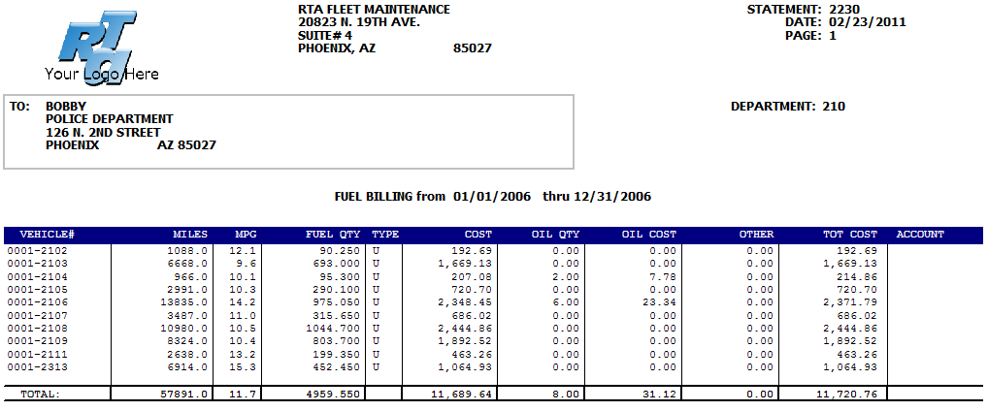

Sample report by department:

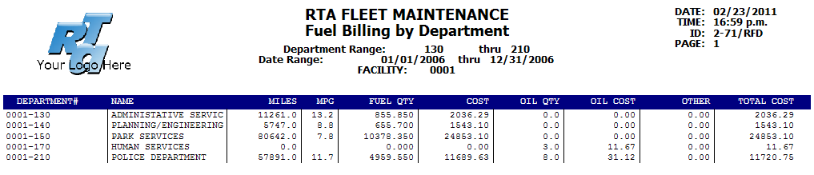

NOTES: Totals section:

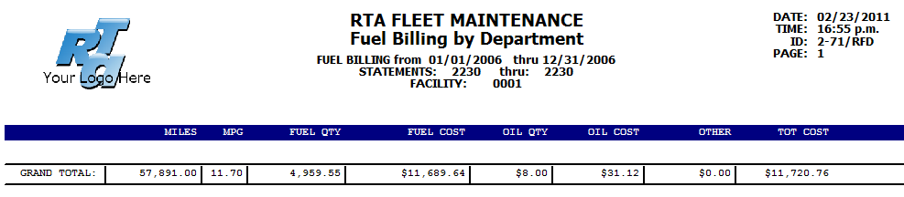

Totals by Fuel Type:

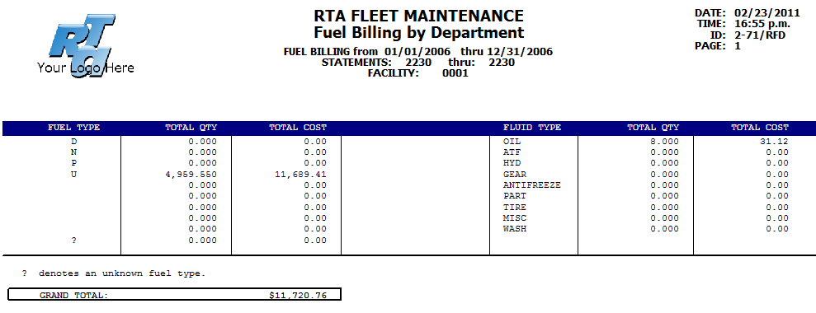

NOTES:

**PARTS INVENTORY LISTS**

MPLx

The parts inventory list programs include sorts by eight different fields, and also include an inventory count sheet. The lists can be processed and sorted by a range of part numbers, fit codes, cross-reference numbers, vendors, bin locations, descriptions, and exclusively for non-stock parts or partkits.

**Total Part Inventory Cost:**

The parts list can be used to calculate your total inventory dollar value: by part number, by bin location, or by part description. In order to retrieve a current value of your parts inventory, process report (MPLL) for the range of *FIRST* to *LAST* and select *Totals Only*. This report can be saved monthly to take a snapshot of the inventory.

The end-of-period process (SEP) can also create a file each time it’s processed to be accessed in Excel, thereby automatically creating a monthly snapshot of the inventory. In the Parts Parameters screen (SSP) set line # 12 to Yes and the file is created each time EOP Parts is processed. The file name is *eompart,* followed by the *facility,* followed by a date and time stamp with an extension of *txt.*

**Parts Physical Inventory Count Sheet:**

The Inventory Count Sheet, option MPLI, is an excellent option for taking a complete physical inventory, or a cycle count. This option prints parts for a bin range and includes a field to mark the inventory quantity counted. The prompt *With Totals* determines whether or not the quantity on-hand currently in the system will be shown. For complete annual inventories, we recommend that this prompt is answered *NO*. The quantity-on-hand columns will then be left blank. For cycle counts, this can be answered *YES* to print the quantity-on-hand, which may make the inventory process faster, but may not be as accurate. If multiple stocking areas are used, select the “All stock areas” option. If only one stocking area is being used, select the “Stock area A” option for a more concise list.

**LOW-USE PARTS LIST**

RPL

The Low-Use Parts report will assist you in lowering your inventory value by identifying parts that have not been used within a certain timeframe. Check the “Last Periods” to identify those not used in the last x consecutive periods; check the “All Periods” to identify those that have not been used in x of the last 12 periods. The prompts include a starting and ending vendor range, and periods to search for “no usage”. We recommend searching for the maximum number of periods for “no usage” the first time this report is processed, and *view* it prior to printing, as it may be much larger than you think! If you are running a 12 period (month) per year cycle in RTA, input 12 in the periods to search for. Each of the parts listed has not been used the past year, many of which could not be stocked and/or returned to the vendor.

NOTES:

## VENDOR QUOTE SHEET

PPE

The Vendor Quote Sheet can be provided to vendors to quote price and availability of parts. In the Edit Requisitions screen (PPE), a new button is available for a Quote Sheet. Select the vendor and the items on requisition to provide a quote for. The vendor can fill in the price, quantity available and/or an estimated delivery date. These lists can be provided to numerous vendors to facilitate the best pricing and availability of parts to be reordered.

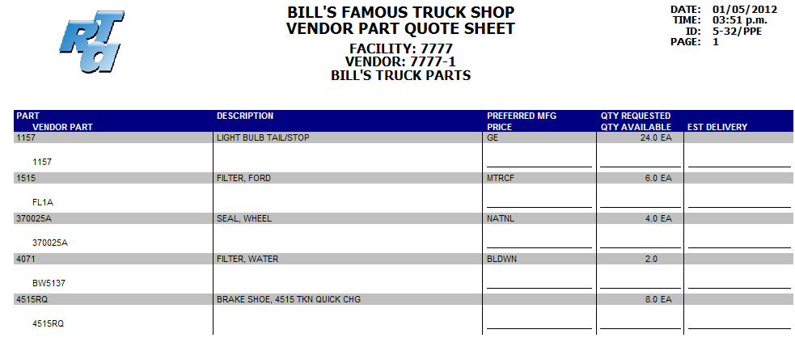

**OPEN PO LINES REPORT**

PPL

The Open PO Lines report lists parts that are currently on order in a PO. This is a great tool to identify older pending orders that may have been forgotten, finding the PO number for an incoming part, and simply to track what is outstanding. It can be processed for a range of facilities, and either for a range of parts or for specific vendors.

DATE: 01/01/2015 RON TURLEY ASSOCIATES ID: 5-276/PPL PAGE: 1

TIME: 11:07 a.m. Open Purchase Order Lines Report

FACILITY: 7777

VENDOR NUMBER: First TO Last

VENDOR PART NUMBER DESCRIPTION PURCHASE ORDER DATE ORDER QTY PRICE TOTAL

------------------------- ---------------------------------------- --------------- ---------- --------- ----------- ----------------

VENDOR: 7777-0000000001 BILL'S TRUCK PARTS

3271 FILTER, FUEL 0000000651-0000 03/03/2014 2.0 9.00 $18.00

7231 BATTERY, GROUP 31 STUD 0000000651-0000 03/03/2014 3.0 85.00 $255.00

ZZ7231 CORE, BATTERY 0000000651-0000 03/03/2014 3.0 9.00 $27.00

------------------------- ---------------------------------------- --------------- ---------- --------- ----------- ----------------

VENDOR: 7777-0000000007 BILL'S AUTO PARTS

1516 FILTER, OIL 0000000988-0000 07/12/2014 5.0 6.00 $30.00

1515 FILTER, OIL 0000000555-0000 11/11/2014 7.0 8.89 $62.23

TOTALS FOR FACILITY: 7777 OPEN LINES: 5 TOTAL COST: $392.23

NOTES:

## PO TRANSACTIONS REPORT

RPT

The PO Transactions report prints every item received in a purchase order for a given date range or part number range. This report can be utilized to acquire a list and total dollar value of all purchases for a month when processed by date range. When running the report by part number, this becomes a great tool in checking the total quantity of purchases for a specific part, and checking price trends.

A “Totals Only” option is available to exclude the detail.

This report, when used in conjunction with the Parts Usage and the Parts Adjustment reports, give the entire history of a given part (if the Manual Parts Chargeout option is used, include the Manual Parts Chargeout Report).

#### Tip: Include Tax: If the switch to add the tax in the part price is set to Yes (SSP line 24), the price shown on this report includes tax.

#### Tip: Include Freight: If freight is added to the part price, the price shown on this report includes freight.

#### Tip: Non-File Purchases

RTA’s Purchase Order module can be used for much more than purchasing inventory parts. Non-file parts can be ordered and received in a purchase order, thus tracking the expenses of other items such as tools, shop supplies and non-chargeables, or office supplies and equipment. When a shop tool is purchased, this non-file “part” can be received under the part number of TOOL, leaving it as a non-file part with the description being the name of the tool. The PO Transactions report can then print a list of all tools purchased, giving the description, cost of the item, when it was purchased and from which vendor.

Sample PO Transactions report:

DATE: 12/27/2014 RON TURLEY ASSOCIATES ID: 5-271/RPT PAGE: 1

TIME: 09:13 a.m. PURCHASE ORDER TRANSACTIONS

FACILITY: 0001

FROM FIRST TO LAST

PART NUMBER DESCRIPTION

TRANS NUM DATE STT PO-NUMBER VENDOR QUANTITY PART-COST TOTAL-COST INVOICE NBR PO-LN ACCOUNT NUMBER

------------------------- --------------- --------------- -------- ---------- ----------- ----------- -------------------------

10231160 MIRROR OUTSIDE L/S

100390 04/28/2014 Y 0000000253 0001-0000000007 1.0 71.25 71.25 42330

10239 RADIATOR CAP

100460 06/04/2014 Y 0000000236 0001-0000000109 2.0 5.43 10.86 477999

10296465 CAP

101281 02/11/2014 Y 0000000510 0001-0000000001 1.0 257.40 257.40 235324 42330

10493 YOKE END PTO

100957 07/29/2014 Y 0000000335 0001-0000000112 1.0 1.33 1.33 42330

10W30 OIL MOTOR 10W30

100834 09/16/2014 Y 0000000347 0001-0000000107 2000.0 0.00 0.00 123876

101019 10/05/2014 P 0000000502 0001-0000000117 440.0 1.20 526.94 85214 160

101194 12/01/2014 Y 0000000502 0001-0000000117 440.0 1.11 489.98 85214 160

101197 12/02/2014 Y 0000000589 0001-0000000117 2108.0 1.20 2524.33 5241 160

NOTES:

**PO RECEIPTS BY INVOICE/VENDOR**

RPR

The PO Receipts by Invoice/Vendor report prints purchase order receipt transactions and calculates subtotals by invoice number and vendor. The subtotals can be used for payments making this report extremely useful for the accounts payable department. The PO receipts can be sorted by date or by vendor. The report prompts for a date range and starting and ending vendor and invoice number.

#### Tip: Include Tax: If the switch to add the tax in the part price is set to Yes (SSP line 24), the price shown on this report includes tax.

#### Tip: Include Freight: If freight is added to the part price, the price shown on this report includes freight.

Sample PO Receipts by Invoice/Vendor:

DATE: 01/27/2015 RON TURLEY ASSOCIATES ID: 5-274/RPR PAGE: 2

Time: 09:21 a.m. Receipts by Date/Invoice/Vendor

Date Rng : 12/01/2044 thru Last Vendor Rng :0001-0000000000 thru 0001-9999999999 Invoice Rng : First thru Last

INVOICE# VENDOR PO-NUMBER DATE PART NUMBER DESCRIPTION STT QTY PART-COST TOTAL-COST

------------------------------------------------------------------------------------------------------------------------------------

52413 0000000109 0000000591 12/02/2014 13974 DUST CAP Y 1.0 13.020 13.020

------- ----------

INVOICE 52413 INVOICE TOTAL: 1 $13.020

VENDOR 0001-0000000109 VENDOR TOTAL: 1 $13.020

52841 0000000111 0000000592 12/02/2014 1403114 PULLEY P/S Y 1.0 29.950 29.950

52841 0000000111 0000000592 12/02/2014 15627136 STRAP Y 1.0 8.510 8.510

------- ----------

INVOICE 52841 INVOICE TOTAL: 2 $38.460

VENDOR 0001-0000000111 VENDOR TOTAL: 2 $38.460

85417 0000000114 0000000593 12/02/2014 5396EL13111X COMPRESOR AIR Y 1.0 238.000 238.000

85417 0000000114 0000000593 12/02/2014 60338 HOSE RADIATOR Y 1.0 11.910 11.910

------- ----------

INVOICE 85417 INVOICE TOTAL: 2 $249.910

VENDOR 0001-0000000114 VENDOR TOTAL: 2 $249.910

5241 0000000117 0000000589 12/02/2014 10W30 OIL MOTOR 10W30 Y 2108.0 1.197 2524.330

------- ----------

INVOICE 5241 INVOICE TOTAL: 2108 $2524.330

VENDOR 0001-0000000117 VENDOR TOTAL: 2108 $2524.330

0000000103 0000000596 12/03/2014 OUT-LABOR 4445-X400 Y 1.0 200.000 200.000

0000000103 0000000596 12/03/2014 OUT-PARTS 4445-X400 Y 1.0 100.000 100.000

0000000103 0000000596 12/03/2014 OUT-TIRES 4445-X400 Y 1.0 300.000 300.000

------- ----------

INVOICE INVOICE TOTAL: 3 $600.000

NOTES:

**PO RECEIPTS BY ACCOUNT NUMBER**

RPN

The PO Receipts by Account Number report prints purchase order receipt transactions and calculates subtotals by part account numbers. The subtotals can be used for payments making this report extremely useful for the accounts payable department. The PO receipts can be sorted by date or by vendor. The report prompts for a date range and starting and ending vendor and invoice number.

The report sorts by account number, then by purchase order number. One purchase order could appear within multiple account groups.

#### Tip: Include Tax: If the switch to add the tax in the part price is set to Yes (SSP line 24), the price shown on this report includes tax.

#### Tip: Include Freight: If freight is added to the part price, the price shown on this report includes freight.

DATE: 01/01/2015 RON TURLEY ASSOCIATES ID: RPN/5-275 PAGE: 1

TIME: 10:12 a.m. Purchases by Account Number

Account: First TO Last

Date: 08/01/2013 TO 08/20/2013

Vendor: 0007-First TO 0007-Last

ACCOUNT NUMBER VENDOR / ABBR. INVOICE NUMBER PURCHASE ORDER RCV DATE TOTAL

------------------------- -------------------------- -------------------- -------------------- ---------- ----------------

0007-0000000001 BKTP 42000007 0007-0000000026-0000 08/14/2013 49.20

0007-0000000001 BKTP 4200040 0007-0000000026-0000 08/20/2013 20.00

==================

TOTAL FOR ACCOUNT: $69.20

160 0007-0000000001 BKTP 42000007 0007-0000000026-0000 08/14/2013 151.60

160 0007-0000000001 BKTP 4200040 0007-0000000026-0000 08/20/2013 177.10

-----------------

TOTAL FOR PURCHASE ORDER: 0007-0000000026-0000 397.90

==================

TOTAL FOR ACCOUNT: 160 $328.70

161 0007-0000000007 BKAP 62551 0007-0000000025-0000 08/12/2013 246.40

161 0007-0000000007 BKAP 62551 0007-0000000025-0000 08/12/2013 393.80

-----------------

TOTAL FOR PURCHASE ORDER: 0007-0000000025-0000 640.20

==================

TOTAL FOR ACCOUNT: 161 $640.20

This report can also be printed by “Totals Only”, resulting in the following output.

DATE: 01/01/2015 RON TURLEY ASSOCIATES ID: RPN/5-275 PAGE: 2

TIME: 10:12 a.m. Purchases by Account Number

Account: First TO Last

Date: 08/01/2013 TO 08/20/2013

Vendor: 0007-First TO 0007-Last

G R A N D T O T A L S

ACCOUNT NUMBER TOTAL

--------------------------------------------

$69.20

160 $328.70

161 $640.20

====================

GRAND TOTAL: $1,038.10

NOTES:

**PARTS USAGE REPORT**

RPA

The WO Parts Usage report prints every part posted to a work order over a selected date range. You may choose to print all parts posted, or an individual part. This report can be used to determine which vehicle(s) a particular part was installed, when it was installed, how many times it has been used, or to find a total usage of all parts posted for a given timeframe. The report includes parts from your inventory, non-file parts posted, and outside parts.

Non-file part postings are indicated with an * to help identify them and the totals separate them from inventory parts. A “Totals Only” option is also available to exclude the detail.

This report, when used in conjunction with the PO Transactions and the Parts Adjustment reports, give the entire history of a given part (if the Manual Parts Chargeout option is used, include the Manual Parts Chargeout Report).

DATE: 03/08/2015 RON TURLEY ASSOCIATES ID: 3-414/RPA PAGE: 1

TIME: 01:42 p.m. PART USAGE BY WORK ORDER

PART FACILITY: 0007

PART NUMBER: FIRST TO LAST

DATE: 01/01/2015 TO 03/31/2015

PART NUMBER TRANS DATE DESC WORK ORDER VEHICLE VMRS CODE TYPE QUANTITY PRICE TOTAL

------------------------- ---------- ---- ------------ ------------- ----------- ---- ---------- --------------- -------------------

1515 03/02/2015 0007-0000177 0007-449 066-004-000 P 1.00 5.750 5.750

15W40 03/02/2015 0007-0000177 0007-449 066-004-000 P 52.00 0.905 47.060

15W40 03/02/2015 0007-0000177 0007-449 066-004-000 P 5.00 0.905 4.525

1750 03/02/2015 0007-0000177 0007-449 066-004-000 P 1.00 4.780 4.780

1792 03/02/2015 0007-0000177 0007-449 066-004-000 P 1.00 8.470 8.470

3115 03/02/2015 0007-0000177 0007-449 066-004-000 P 1.00 4.950 4.950

3202 02/04/2015 0007-0000175 0007-499 034-009-000 P 1.00 10.364 10.364

3271 02/02/2015 0007-0000172 0007-007 044-024-000 P 1.00 3.990 3.990

3384 03/02/2015 0007-0000177 0007-449 066-004-000 P 1.00 5.810 5.810

3406D 03/02/2015 KIT 0007-0000177 0007-449 066-004-000 P 1.00 0.000 0.000

3406D 03/02/2015 END 0007-0000177 0007-449 066-004-000 P 1.00 0.000 0.000

4071 03/02/2015 0007-0000177 0007-449 066-004-000 P 1.00 4.510 4.510

601877 03/02/2015 0007-0000177 0007-449 051-002-000 P 1.00 3.150 3.150

B2X3 02/02/2015 0007-0000172 0007-007 044-045-000 *P 1.00 18.000 18.000

S4 03/02/2015 0007-0000177 0007-449 015-005-000 OP 1.00 14.000 14.000

M960003 03/05/2015 0007-0000178 0007-499 017-004-000 T 1.00- 0.000 0.000

M960104 03/05/2015 0007-0000178 0007-499 017-004-000 T 1.00 407.400 407.400

GRAND TOTALS

OUTSIDE PARTS QUANTITY: 1.00 TOTAL OUTSIDE PART PRICE: $14.000 TOTAL OUTSIDE TRANSACTIONS: 1

NONFILE PARTS QUANTITY: 1.00 TOTAL NONFILE PART PRICE: $18.000 TOTAL NONFILE TRANSACTIONS: 1

PARTS QUANTITY: 68.00 TOTAL SHOP PRICE: $510.759 TOTAL SHOP TRANSACTIONS: 15

TOTAL QUANTITY: 70.00 TOTAL PRICE: $542.759

**PARTS ADJUSTMENT REPORT**

RPP

The Parts Adjustment report shows all adjustments made to your parts inventory outside of purchase orders and work orders. This report can be processed for a range of part numbers or dates. It can be used to determine an ongoing shrinkage for a particular part (oil?), total dollar changes or as a recount sheet during a physical inventory, and parts history tracking. A “Totals Only” option is available to exclude the detail.

**Transactions written to the Parts Adjustment report:**

* Adding a new part
* Manual Quantity on-hand adjustments
* Tricoder Quantity on-hand adjustments
* Price adjustments
* Part transfers to/from another facility
* Non-chargeable parts posted at EOP
* Parts deleted
* Part usage in the Quick Fuel Entry program
* Initial mount of tire parts mounted to vehicles through tire module

This report, when used in conjunction with the PO Transactions and the Parts Usage reports, give the entire history of a given part (if the Manual Parts Chargeout option is used, include the Manual Parts Chargeout Report).

DATE: 07/28/2013 RON TURLEY ASSOCIATES ID: 5-34/RPP PAGE: 1

TIME: 10:23 a.m. PARTS ADJUSTMENT REPORT

FACILITY: 0329

DATE: 05/01/2013 TO 05/31/2013

PART NUMBER PART NAME TYP TIME DELETED ADDED UNIT PRICE NET CHANGE REASON AUTHORIZED

------------------------- ------------------------ --- ------ --------- --------- ---------- ----------- --------------- ----------

DATE: 05/16/2013

PENNZ 10/30 OIL, PENNZ 10/30 P 2:59pm 425.0 $0.71 $303.02 ADJ PRICE 329RTASYS

PENNZ 10/30 OIL, PENNZ 10/30 J 3:01pm 225.0 $1.58 $356.17-OIL SPILL BILL

DATE TOTALS: 225.0- 425.0 $53.15-

DATE: 05/21/2013

1157 LIGHT BULB TAIL/STOP T 8:39am 2.0 $0.70 $1.40-0329 to 0330 BRIAN

1157 LIGHT BULB TAIL/STOP J 8:53am 1.0 $0.70 $0.70 TCODER BRIAN

B5785 BATTERY A 10:29am 12.0 $50.00 $600.00 ADD PARTS BRIAN

15W40 OIL, MOTOR 15W40 U 12:44pm 1.0 $1.58 $1.58-QUICK-FUEL 401

DATE TOTALS: 3.0- 13.0 $597.72

Grand Total Cost - ADDS > $600.000

Grand Total Cost - DELETES > $0.000

Grand Total Cost - USAGE > $0.000

Grand Total Cost - ADJUSTS > $55.430-

GRAND TOTAL REDUCE AMOUNT > $359.155-

GRAND TOTAL INCREASE AMOUNT > $903.725

GRAND TOTAL NET CHANGE > $544.570

NOTES:

**PARTS ACTIVITY REPORT**

RPC

The Parts Activity Report combines the data discussed in the previous parts reports to give a summary of parts activity. It lists the current inventory, average price, and extended value. The report then calculates “backwards” for the date range specified, adding in the usage, subtracting the purchases, and adding or subtracting the adjustments to determine the starting inventory. This is an excellent tool to analyze parts inventory trends and will help in identifying slow moving parts. This report also creates an ascii file to allow you to import the data into another package to manipulate, formatted as username, 16-digit date/time, .tmp. For example, BILL2010030912345678.tmp.

Note: This report reads transactions from work orders, adjustments, and purchase order receipts to calculate the beginning inventory. Therefore, if any of these files have had data deleted within the specified date range, the numbers may be incorrect.

DATE: 07/28/2013 RON TURLEY ASSOCIATES ID: RPC (5-434) PAGE: 1

TIME: 10:36 a.m. PARTS SUMMARY HISTORY REPORT

FACILITY: 0329

PART NUMBER: FIRST TO LAST

DATE: 01/01/2013 TO 07/28/2013

PART NUMBER BIN LOC. START INV PURCHASES USAGE ADJUST END INV COST TOTAL

------------------------- ---------- ----------- ---------- ---------- ---------- ----------- ---------------- -------------------

1156 A46 9.00- 22.0 5.0 31.0 39.00 $1.242 $48.438

1157 A47 0.00 89.0 1.0 8.0 96.00 $0.700 $67.200

1157A A48 0.00 5.0 0.0 0.0 5.00 $1.082 $5.410

123X5 A19 0.00 5.0 0.0 0.0 5.00 $12.000 $60.000

34987437 B32 23.00 0.0 0.0 11.0 34.00 $25.612 $870.808

4321 J06 3.00 9.0 0.0 6.0 18.00 $13.416 $241.488

4399 6.00 1.0 1.0 6.0 12.00 $2.507 $30.084

AA71 2.00- 0.0 1.0 4.0 1.00 $100.000 $100.000

AC11 C03 143.00 13.0 73.0 2.0- 81.00 $5.439 $440.559

AC12 C04 0.00 6.0 1.0 48.0 53.00 $6.990 $370.470

AE12V650 D03 1.00 2.0 2.0 0.0 1.00 $75.333 $75.333

B102 D12 14.00- 3.0 5.0 18.0 2.00 $50.000 $100.000

B105 D13 0.00 12.0 0.0 43.0 55.00 $1.309 $71.995

B601 D17 0.00 0.0 0.0 3.0 3.00 $4.970 $14.910

BATTERY, KIT A12 0.00 0.0 0.0 2.0 2.00 $85.000 $170.000

BATTERY,CABLE A19 62.00 0.0 0.0 0.0 62.00 $2.300 $142.600

BB64776 G54 1.00 0.0 0.0 15.0 16.00 $1.000 $16.000

BO9645-2 R01 199.00 0.0 0.0 0.0 199.00 $0.250 $49.750

D468683345 F04 80.00- 80.0 0.0 0.0 0.00 $1.123 $0.000

F23-54 12B 48.00 0.0 0.0 3.0 51.00 $11.309 $576.759

K62-A13 A12 0.00 0.0 0.0 0.0 0.00 $29.610 $0.000

N10-44 R06 33.00 0.0 0.0 0.0 33.00 $6.000 $198.000

------------------------------------------------------------------------------------------------------------------------------------

START INV PURCHASES USAGE ADJUST END INV GRAND TOTAL

------------- ---------- ---------- ---------- ------------- --------------

GRAND TOTAL 986.000- 1647.0 89.0 196.0 768.000 3649.804

NOTES:

**PARTS GAIN/LOSS REPORT**

RPG

The Parts Usage Gain/Loss report is used in conjunction with markups when charging out parts on work orders. This report is used to calculate profit dollars and percentages that may be used to determine if your internal markup values are enough. The markups may be applied to individual parts, customers, non-file parts markups, or markups posted manually when charging them in work orders. The report lists the totals for each transaction’s charged price (with markups), actual price (average of part *cost*), gain or loss total in dollars, and the percentage of the gain or loss. Outside parts are not included. A “Totals Only” option is available to exclude the detail. The report can be sorted by date or VMRS code.

If the intent of parts markups is to generate enough revenue to cover the parts room salaries, print this report quarterly or yearly to compare with those salaries.

Sample Parts Usage Report:

DATE: 07/28/2013 RON TURLEY ASSOCIATES ID: 3-415/RPG PAGE: 1

TIME: 10:52 a.m. WORK ORDER PART USAGE GAIN/LOSS SUMMARY REPORT

FACILITY: 0329

PART NUMBER: FIRST TO LAST

DATE: 06/01/2013 TO 06/30/2013

WORK ORDER VEHICLE PART NUMBER JOB CODE QUANTITY CHARGE PRICE ACTUAL PRICE TOTAL GAIN GAIN PCT

---------- ------------- ------------------------- ----------- --------- --------------- --------------- --------------- ----------

TRANSACTION DATE: 06/02/2013

0005189 0329-329 B103 066-001-000 1.00 60.000 50.000 10.000 20.000 %

0005310 0329-329 AE12V650 032-002-000 1.00 60.000 50.000 10.000 20.000 %

TRANSACTION DATE: 06/03/2013

0005046 3299-330 AC11 032-002-000 1.00 100.000 100.000 0.000 0.000 %

0005046 3299-336 AA647758 032-002-000 1.00 100.000 100.000 0.000 0.000 %

TRANSACTION DATE: 06/06/2013

0005116 0329-329 A67466 045-005-000 1.00 44.800 32.000 12.800 40.000 %

0005164 3299-332XX B106 001-001-000 1.00 50.000 50.000 0.000 0.000 %

0005164 3299-332XX 23423434 001-001-000 1.00 79.200 66.000 13.200 20.000 %

0005164 3299-332XX 5345345 001-001-000 1.00 4.800 4.000 0.800 20.000 %

0005185 0329-329 V99-35 017-000-000 1.00 11.172 9.310 1.862 20.000 %

0005200 0329-3388 BX96843 001-002-000 1.00 60.000 50.000 10.000 20.000 %

0005200 0329-3388 BX94450 001-002-000 1.00 60.000 50.000 10.000 20.000 %

0005234 3298-007 CH583 001-001-000 1.00 50.000 50.000 0.000 0.000 %

0005234 3298-007 BX97769 001-001-000 1.00 50.000 50.000 0.000 0.000 %

0005234 3298-007 5847273 001-001-000 1.00 50.000 50.000 0.000 0.000 %

TRANSACTION DATE: 06/16/2013

0005046 3299-330 1156 032-002-000 1.00 2.703 2.676 0.027 1.008 %

0005189 0329-329 B103 032-002-000 1.00 60.000 50.000 10.000 20.000 %

0005233 5495-002 B199 001-001-000 1.00 50.000 50.000 0.000 0.000 %

0005318 0329-329 1156 027-000-000 1.00 2.412 1.990 0.422 21.206 %

TRANSACTION DATE: 06/23/2013

0005046 3299-330 1156 032-002-000 1.00 1.083 1.083 0.000 0.000 %

0005265 0329-443 1156 027-000-000 3.00 3.900 3.249 0.651 20.036 %

TRANSACTION DATE: 06/26/2013

0005185 0329-329 AE12V650 017-000-000 1.00 60.000 50.000 10.000 20.000 %

0005326 0329-329 1156 001-001-000 1.00 1.490 1.242 0.248 19.967 %

TRANSACTION DATE: 06/28/2013

0005338 0329-329 1157 032-002-000 1.00 0.840 0.700 0.140 20.000 %

0005338 0329-329 1156 032-002-000 1.00 1.490 1.242 0.248 19.967 %

GRAND TOTALS

TOTAL TRANSACTIONS: 25 TOTAL CHARGE PART PRICE: $963.890

PARTS QUANTITY: 27.00 TOTAL ACTUAL PART PRICE: $873.492

==================

TOTAL GAIN/LOSS: $90.398

GAIN/LOSS PERCENT: 10.349 %

NOTES:

**PARTS WARRANTY REPORTS**

RWP, RWF, RWT

**Warranty Parts Report (RWP):**

This report lists all warranted parts that are currently installed. It can be processed for a range of parts to determine which vehicles the parts are currently on. It can also be processed for a range of vehicles to show all warranted parts currently installed. The *S-MILES* and *S-MONTHS* display the service life since the part was installed on the vehicle. Therefore, this report can also be used to plan part replacements.

DATE: 01/09/2012 ID: 5-81/RWP PAGE: 1

TIME: 11:41 a.m. W A R R A N T Y P A R T S

FACILITY: 0007

PART NUMBER: FIRST TO LAST

------------------------------------------------------------------------------------------------------------------------------------

PART: 0007-4515RQ DESCRIPTION: BRAKE SHOE, 4515 TKN QUICK CHG

VEHICLE NUMBER POS VMRS CODE INSTALL MOUNTED COST WORK ORDER PO NUMBER VENDOR S-MILES S-MONTHS

0007-449 013-075-000 03/01/2007 222003 22.21 0007-0000183 0000007 0007-0000000001 0.0 58.4

0007-499 013-075-000 03/21/1996 126715 23.32 0007-0000032 0000000002 0007-0000000001 79707.0 89.9

0007-357 013-750-020 09/13/1999 675024 23.32 0007-0000045 0000000002 0007-0000000001 17987.0 48.1

PART: 0007-7231 DESCRIPTION: BATTERY, GROUP 31 STUD

VEHICLE NUMBER POS VMRS CODE INSTALL MOUNTED COST WORK ORDER PO NUMBER VENDOR S-MILES S-MONTHS

0007-007 032-002-000 07/31/1996 28904 92.97 0007-0000028 0000000005 0007-0000000001 27797.0 185.5

0007-449 032-002-000 01/02/1996 89542 92.97 0007-0000025 0000000000 0007-0000000001 132461.0 182.5

0007-499 032-002-000 07/31/1996 126715 92.97 0007-0000032 0000000005 0007-0000000001 79707.0 185.5

0999-008 032-002-000 03/12/2000 69857 88.55 0007-0000057 0000000006 0007-0000000001 6277.0 142.1

PART: 0007-7232 DESCRIPTION: BATTERY, GROUP 31 POST

VEHICLE NUMBER POS VMRS CODE INSTALL MOUNTED COST WORK ORDER PO NUMBER VENDOR S-MILES S-MONTHS

0007-R357 032-002-000 03/21/1996 5895 92.97 0007-0000026 0000000000 0007-0000000001 1946.0 189.9

0007-450 02 032-002-000 03/19/2009 214881 88.55 0007-0000187 0000026 0007-0000000001 0.0 33.8

0007-450 20 032-002-000 03/19/2009 214881 88.55 0007-0000187 0000026 0007-0000000001 0.0 33.8

0007-450 51 032-002-000 03/19/2009 214881 88.55 0007-0000187 0000026 0007-0000000001 0.0 33.8

PART: 0007-D2 DESCRIPTION: VALVE, AIR GOVERNOR

VEHICLE NUMBER POS VMRS CODE INSTALL MOUNTED COST WORK ORDER PO NUMBER VENDOR S-MILES S-MONTHS

0007-450 013-094-000 03/19/2009 214881 21.56 0007-0000187 0000000059 0007-0000000001 0.0 33.8

0007-449 013-094-000 03/19/2009 222003 21.56 0007-0000177 0000000059 0007-0000000001 0.0 33.8

**Component History Report/Failure Statistics (RWF):**

The Component History report shows the failure statistics for warranty parts, which may also be viewed in the parts master screen (MPM) by clicking on the *View Warranty Stats* button. Each column lists how many have failed within that mileage or month. For example, in the report below, the column for “41,142+” shows that between the mileage of 41,142 and 61,713, two batteries have failed this month, 6 have failed this year, and 9 have failed life to date.

This report tracks the failure statistics even after the warranty has expired. Notice in the example that the warranty is for 72,000 miles or 36 months. The actual warranty always falls between the fourth and fifth column, but the failures are still tracked for the life of all warranty parts.

This report can also be used to *schedule* parts replacement to prevent costly road calls and down time. Noting where the failure numbers are the largest may assist you in developing a scheduled replacement time and/or mileage.

DATE: 01/01/2015 RON TURLEY ASSOCIATES ID: 5-82/RWF PAGE: 1

TIME: 11:57 a.m. COMPONENT HISTORY REPORTS

FACILITY: 0007

PART NUMBER: FIRST TO LAST

------------------------------------------------------------------------------------------------------------------------------------

PART NUMBER: 7231 DESCRIPTION: BATTERY, GROUP 31 STUD

MILES BF: 72000 MONTHS BF: 36 LAST UPDATE: 09/17/2001

PRD T-MILES T-MTH T-COST MLS: 0+ 20571+ 41142+ 61713+ 82284+102855+123426+ MTH: 0+ 10+ 20+ 30+ 40+ 50+ 60+

--- --------- ----- ---------- ------ ------ ------ ------ ------ ------ ------ ------ ------ ------ ------ ------ ------ ------

CRT 0 0 0.00 0 1 2 1 1 0 0 0 2 1 0 1 1 0

YTD 0 0 0.00 0 1 6 5 5 4 2 1 2 1 4 6 3 3

LTD 0 0 0.00 0 3 9 13 11 8 3 1 4 4 12 12 6 5

**Warranty Transaction Report (RWT)**

This report shows each warranty part installed for a part number or date range. This report can be printed daily or weekly to determine which parts removed were covered by a warranty. Notice the right side of the report quickly shows which are still within the warranty. If this is the first warranted part of this type installed on a vehicle, it displays “?? original ??” for the previous part number.

DATE: 01/09/2012 ID: 5-83/RWT PAGE: 1

TIME: 11:48 a.m. COMPONENT TRANSACTION REPORTS

FACILITY: 0007

PART NUMBER: 7231

------------------------------------------------------------------------------------------------------------------------------------

DESC:BATTERY, GROUP 31 STUD VEH: 0007-008 MFG-BF (miles): 0 (months): 0 MSG: may have a warranty.

PART NUMBER POS INSTALL WORK ORDER VENDOR PO NUMBER MECHANIC MILES MNTH COST

------------------------------ ---- ---------- ------------ ---------- ---------- ---------- ------- ---- --------

OLD: ?? original ?? 00/00/0000 0007-0000000 0000000000 0 0

NEW: 0007-7231 03/12/2000 0007-0000057 0000000001 0000000006

DESC:BATTERY, GROUP 31 STUD VEH: 0007-450 MFG-BF (miles): 0 (months): 0 MSG: may have a warranty.

PART NUMBER POS INSTALL WORK ORDER VENDOR PO NUMBER MECHANIC MILES MNTH COST

------------------------------ ---- ---------- ------------ ---------- ---------- ---------- ------- ---- --------

OLD: 0007-?? original ?? 00/00/0000 0007- 0000000000 0 0

NEW: 0007-7231 02/14/2007 0007-0000187 0000000001 0000006 0000000002

DESC:BATTERY, GROUP 31 STUD VEH: 0007-450 MFG-BF (miles): 72000 (months): 36 MSG: within WARRANTY !!!

PART NUMBER POS INSTALL WORK ORDER VENDOR PO NUMBER MECHANIC MILES MNTH COST

------------------------------ ---- ---------- ------------ ---------- ---------- ---------- ------- ---- --------

OLD: 0007-7231 02/14/2007 0007-0000187 0000000001 0000006 0 0 88.55

NEW: 0007-7231 03/01/2007 0007-0000187 0000000001 0000000054 0000000002

DESC:BATTERY, GROUP 31 STUD VEH: 0007-049 MFG-BF (miles): 50000 (months): 36 MSG: within WARRANTY !!!

PART NUMBER POS INSTALL WORK ORDER VENDOR PO NUMBER MECHANIC MILES MNTH COST

------------------------------ ---- ---------- ------------ ---------- ---------- ---------- ------- ---- --------

OLD: 0007-7231 03/13/1995 0007-0000391 0000105000 0000000005 6000 5 92.40

NEW: 0007-7231 08/22/1995 0007-0000391 0000105000 0000000005

DESC:BATTERY, GROUP 31 STUD VEH: 0007-163 MFG-BF (miles): 0 (months): 0 MSG: may have a warranty.

PART NUMBER POS INSTALL WORK ORDER VENDOR PO NUMBER MECHANIC MILES MNTH COST

------------------------------ ---- ---------- ------------ ---------- ---------- ---------- ------- ---- --------

OLD: ?? original ?? 00/00/2000 0007-0000000 0000000000 0 0

NEW: 0007-7231 10/02/1995 0007-0030390 0000105000 0000000005 0000000007

NOTES: